HTML5 ASSIGNMENT

1. What are the new tags added in HTML5?

A HTML5 new tags

1. HTML Declaration

<!DOCTYPE html>

<article>

<aside>

<details>

<footer>

<header>

<main>

<mark>

<nav>

<section>

<time>

<output>

<canvas>

<svg>

<audio>

<video>

1. How to embed audio and video in a webpage?

A The <audio> and <video> tags make it simple to add audio and video to a website. You need to set src attribute to

identify the media source and include a controls attribute so the user can play and pause the media.

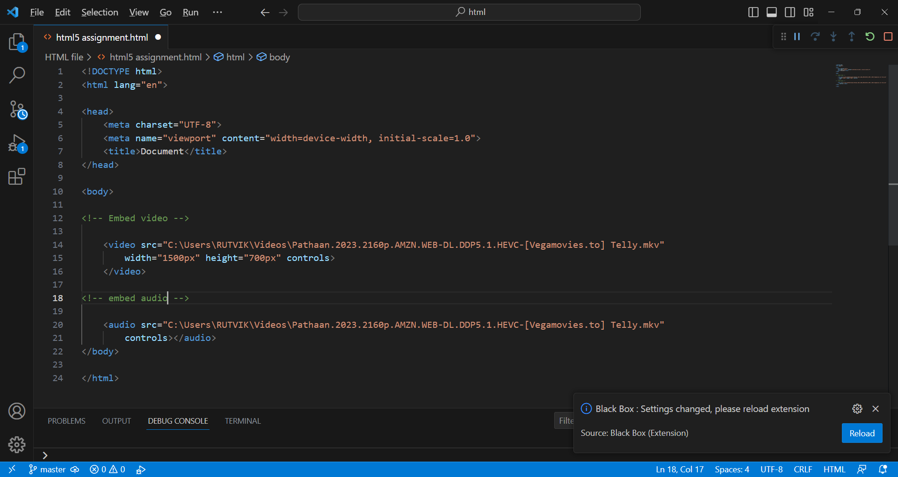

1. Semantic element in HTML5?

A Semantic elements = elements with a meaning.

Examples of semantic elements: <form>, <table>, and <article> - Clearly defines its content.

* <article> - defines independent, self-contained content
* <aside> - defines content aside from the page content
* <details> - define additional details that the user can view or hide
* <footer> - define a footer for a document or section
* <header> - specifies a header for a document or section
* <main> - specifies the main content of a document
* <mark> - defines highlighted text
* <nav> - defines navigation links
* <section> - defines a section in a document
* <time> - defines a date/time

1. Canvas and SVG tags?

A SVG

* SVG stands for scalable vector graphics
* SVG is used to define graphics for the web
* The HTML <svg> element is a container fir SVG graphics.
* SVG has several methods for drawing paths, boxes, circles, text, and graphic images.

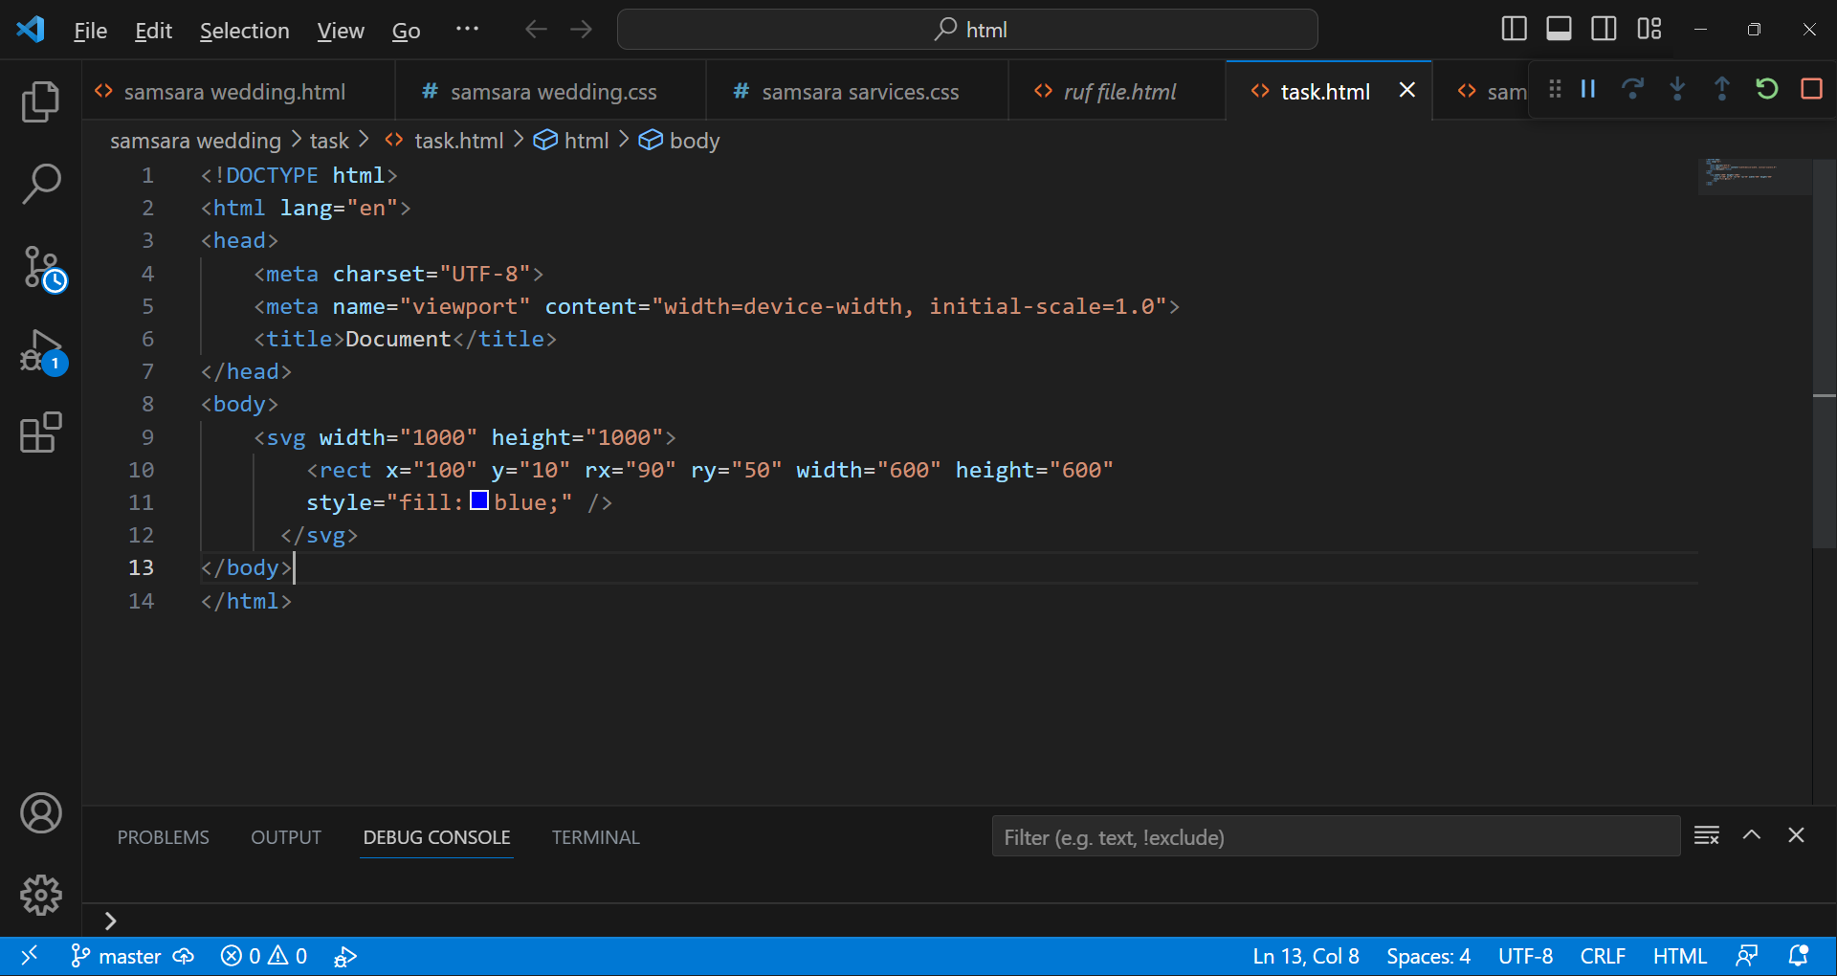

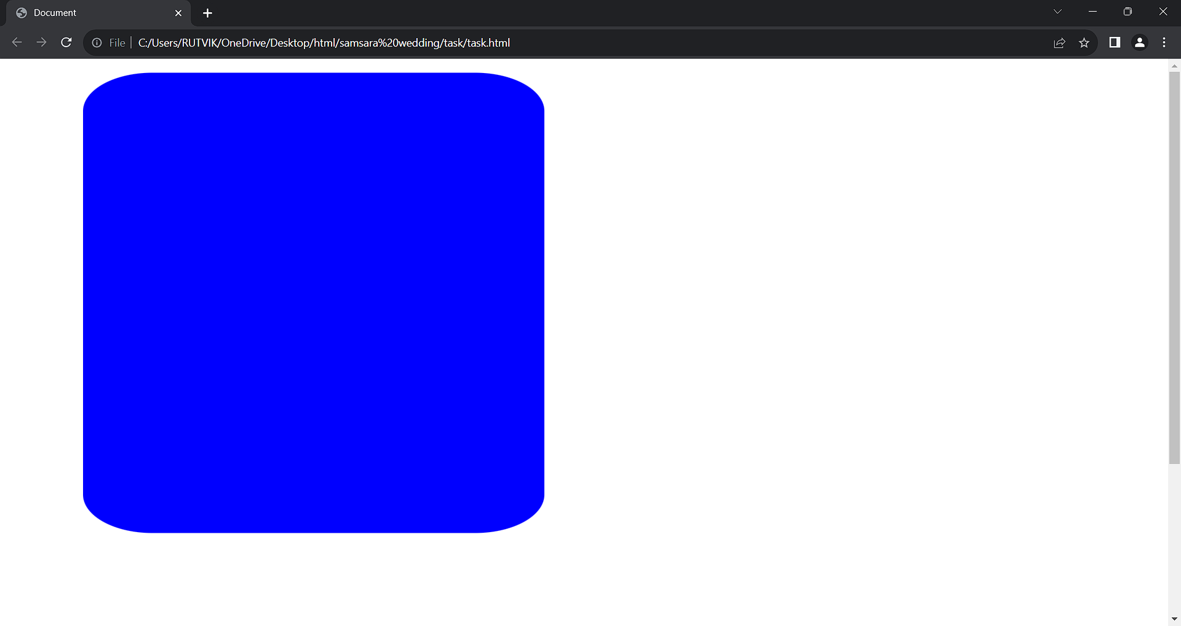

A CANVAS

* Canvas has several methods for drawing paths, boxes, circles, text, and adding images.
* The <canvas> element is only a container for graphics. You must use JavaScript to actually draw the graphics.
* The HTML <canvas > element is used to draw graphics on a web page.

